ADITHYA R
192311369

Change Hardware compatibility of a VM (Either by clone/create new one) which is already created and configured, using virtual box.
AIM: To change the hardware compatibility of an existing virtual machine in VirtualBox by modifying settings or creating a clone with updated hardware configuration.
PROCEDURE:
*Open VirtualBox and select the VM whose hardware compatibility you want to change.
*Option 1 – Modify Existing VM:
  - Right-click the VM → Settings → System / Processor / Display / Storage / Network.
  - Change desired hardware settings (e.g., increase RAM, CPU cores, or video memory).
  - Click OK to save changes.
*Option 2 – Clone with Updated Hardware:
  - Right-click the VM → Clone, give a new name → choose Full Clone.
  - After cloning, go to Settings of the cloned VM and modify the hardware configuration as needed.
*Start the VM to ensure it runs correctly with the new hardware settings.
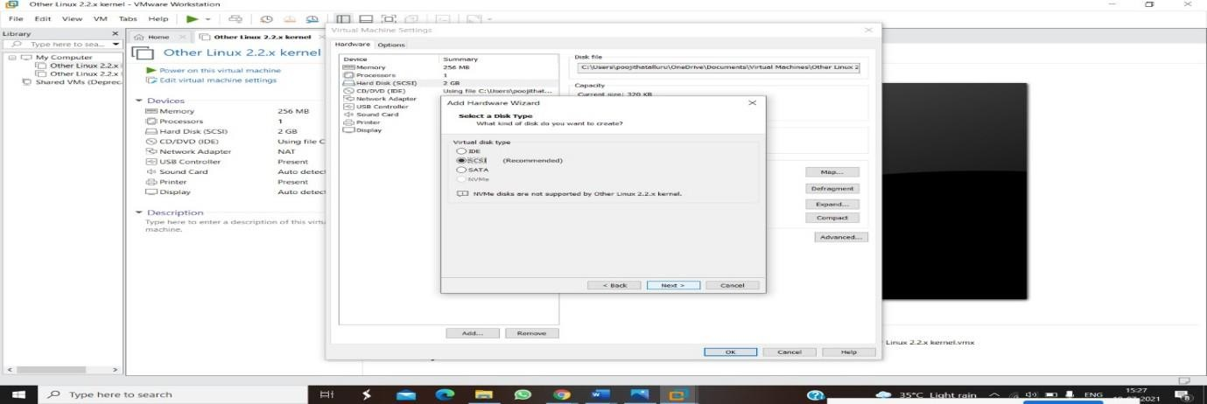
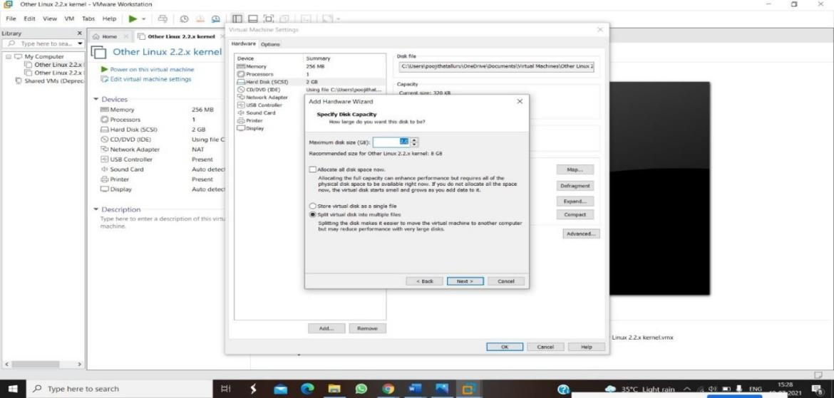

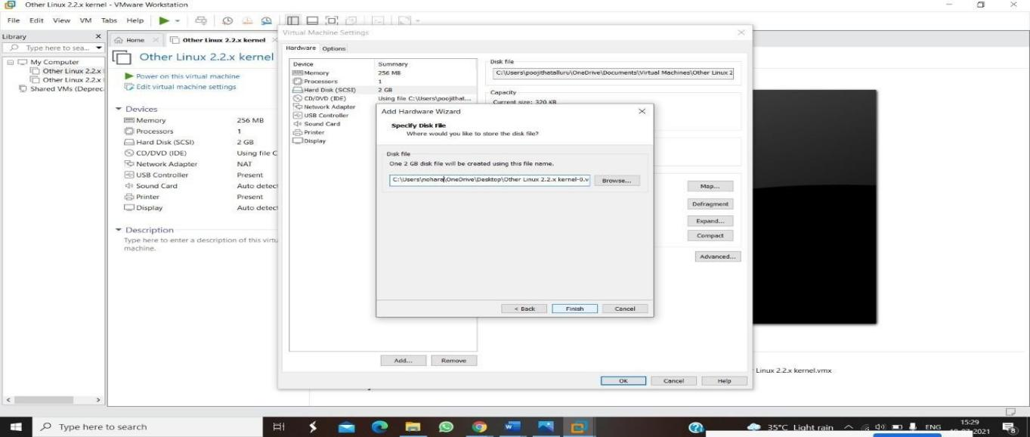

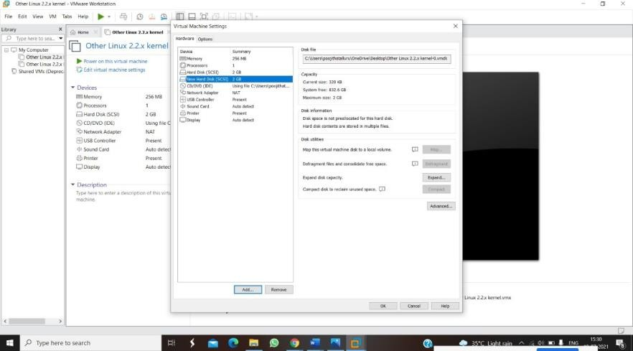

RESULT:
- The VM hardware configuration is successfully updated.
- The original VM remains unchanged (if cloned), while the modified or cloned VM operates with the new CPU, RAM, storage, or other hardware settings.
- The VM starts without errors, confirming the hardware compatibility changes were effective.

